Anonymous Proxy

🕵️ What is an Anonymous Proxy?
# Source: Chatgpt (GPT-5-Mini) at [1/16/2026]
An Anonymous Proxy is a type of proxy server that hides your IP address from the websites you visit. It forwards your requests to the internet on your behalf without revealing your identity to the target server.
📌 Think of it as a privacy mask: The website you visit sees only the proxy's IP, not yours.

🧠 How It Works
# Source: Chatgpt (GPT-5-Mini) at [1/16/2026]
You → Anonymous Proxy → Website → Proxy → You

- The website thinks the request is coming from the proxy.
- Your real IP address is hidden.

🔐 Key Features
# Source: Chatgpt (GPT-5-Mini) at [1/16/2026]
Feature | Anonymous Proxy
✅ Hides your IP | Yes – websites only see the proxy's IP
❌ Doesn’t reveal you’re using a proxy | Some headers still show it's a proxy
🔁 Passes requests | Just forwards them (usually HTTP/S only)
🧩 Not encrypted | Often no encryption unless used with HTTPS

🆚 Types of Proxy by Anonymity
# Source: Chatgpt (GPT-5-Mini) at [1/16/2026]
Proxy Type | IP Hidden? | Reveals It's a Proxy? | Notes
Transparent Proxy | ❌ No | ✅ Yes | No privacy, for control only
Anonymous Proxy | ✅ Yes | ✅ Yes | Hides IP, but detectable
Elite Proxy (High Anonymity) | ✅ Yes | ❌ No | Best for privacy

🧩 Use Cases of Anonymous Proxies
# Source: Chatgpt (GPT-5-Mini) at [1/16/2026]
Use Case | Description
🌐 Private Browsing | Avoid tracking by websites
🌍 Bypass Geo-blocks | Access content unavailable in your region
🛑 Bypass Firewalls | Access restricted websites
🚫 Avoid IP bans or rate limits | Hide real identity from websites

⚠️ Limitations
# Source: Chatgpt (GPT-5-Mini) at [1/16/2026]
- ❌ May not encrypt data unless you use HTTPS
- ❌ Many websites block known proxy IPs
- ⚠️ Still detectable with headers (like X-Forwarded-For)

🧪 Examples of Public Anonymous Proxies
# Source: Chatgpt (GPT-5-Mini) at [1/16/2026]

Website | Description
https://hidemy.name | Free proxy list by country, anonymity level
https://free-proxy-list.net | Huge list, includes HTTPS & anonymity rating
https://spys.one | Technical, filters by port/country/type
https://proxy-list.download | Offers HTTP/SOCKS4/5 free proxies

📌 How to Use (in a Browser)
# Source: Chatgpt (GPT-5-Mini) at [1/16/2026]
- Pick an HTTP/HTTPS anonymous proxy
- Go to browser settings → Network or Proxy
- Enter the proxy IP & port
- Save and test by visiting https://whatismyipaddress.com
✅ If it shows the proxy IP instead of yours — it’s working.

Set Up Your Own Anonymous Proxy (Using Squid on Ubuntu)

🐧 Install Squid Proxy Server
# Source: Chatgpt (GPT-5-Mini) at [1/16/2026]
sudo apt update
sudo apt install squid

⚙️ Configure Squid as Anonymous Proxy
# Source: Chatgpt (GPT-5-Mini) at [1/16/2026]
Edit the config file:
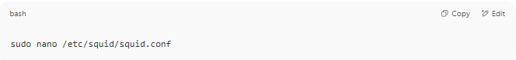
sudo nano /etc/squid/squid.conf
Add or modify the following:
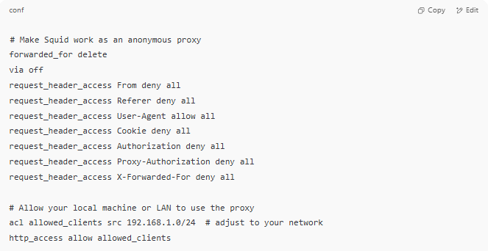
# Make Squid work as an anonymous proxy
forwarded_for delete
via off
request_header_access From deny all
request_header_access Referer deny all
request_header_access User-Agent allow all
request_header_access Cookie deny all
request_header_access Authorization deny all
request_header_access Proxy-Authorization deny all
request_header_access X-Forwarded-For deny all

# Allow your local machine or LAN to use the proxy
acl allowed_clients src 192.168.1.0/24 # adjust to your network
http_access allow allowed_clients

Then restart Squid:
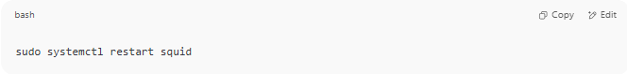
sudo systemctl restart squid

🔌 Connect a Browser to Your Squid Proxy
# Source: Chatgpt (GPT-5-Mini) at [1/16/2026]
- Go to browser → Proxy Settings
- Use the IP address of your proxy server and port (default is 3128)
- Browse anonymously!

🪟 Set Up Your Own Anonymous Proxy with Authentication (on Windows)

📦 Step 1: Download & Install Squid for Windows
# Source: Chatgpt (GPT-5-Mini) at [1/16/2026]
- Download from:
👉 https://squid.acmeconsulting.it/download/
- Extract it to C:\Squid or similar.
- Open cmd as Administrator.
Run:
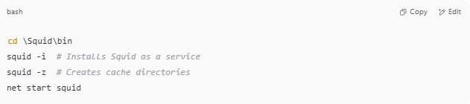
cd \Squid\bin
squid -i # Installs Squid as a service
squid -z # Creates cache directories
net start squid

⚙️ Step 2: Configure Squid for Anonymity + Authentication
# Source: Chatgpt (GPT-5-Mini) at [1/16/2026]
Edit:
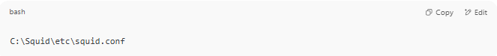
C:\Squid\etc\squid.conf

🔧 Update or add the following config:
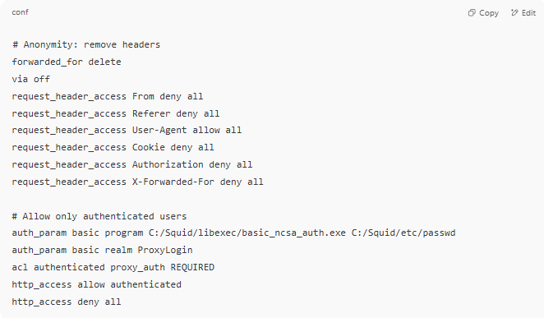
# Anonymity: remove headers
forwarded_for delete
via off
request_header_access From deny all
request_header_access Referer deny all
request_header_access User-Agent allow all
request_header_access Cookie deny all
request_header_access Authorization deny all
request_header_access X-Forwarded-For deny all

# Allow only authenticated users
auth_param basic program C:/Squid/libexec/basic_ncsa_auth.exe C:/Squid/etc/passwd
auth_param basic realm ProxyLogin
acl authenticated proxy_auth REQUIRED
http_access allow authenticated
http_access deny all

👤 Step 3: Create Proxy Username & Password
# Source: Chatgpt (GPT-5-Mini) at [1/16/2026]
- Open Command Prompt and run:
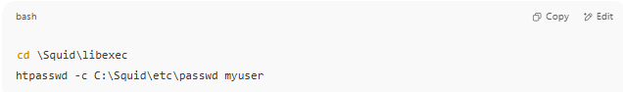
cd \Squid\libexec
htpasswd -c C:\Squid\etc\passwd myuser
- Enter password when prompted.
Now your proxy will require a username (myuser) and password.

🧪 Step 4: Configure Your Browser
# Source: Chatgpt (GPT-5-Mini) at [1/16/2026]
In Firefox / Chrome / Edge:
- Go to Settings → Network → Proxy
- Set:
  - Manual proxy configuration
  - HTTP proxy: localhost or your IP
  - Port: 3128 (default)
- Enter credentials when prompted.

✅ Summary
# Source: Chatgpt (GPT-5-Mini) at [1/16/2026]
Feature | Description
Purpose | Hide user IP address from websites
Level of privacy | Medium
Detectable as proxy | ✅ Yes (headers may reveal it)
Use cases | Privacy, bypassing restrictions, IP hiding

